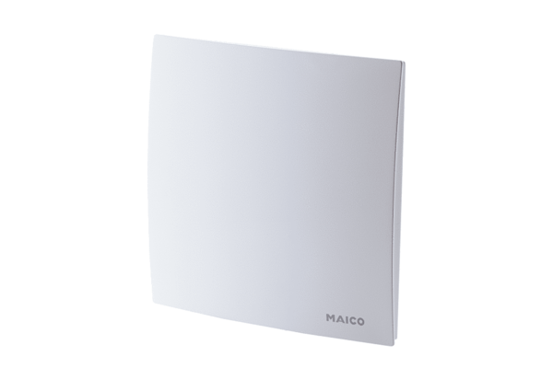Cover ER-APacking unit: 1 pieceRange: B
Article number: 0084.0361Manufacturer: MAICO

