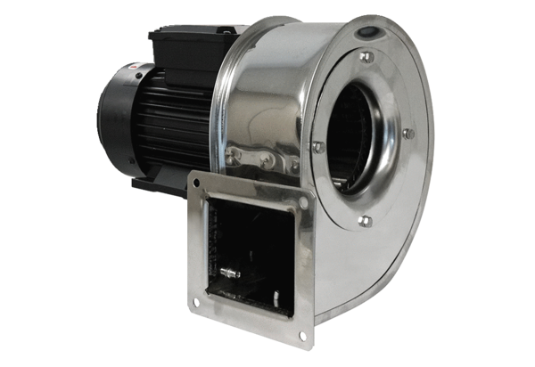Centrifugal blower GRM ES 14/2 DPacking unit: 1 pieceRange: C
Article number: 0073.0322Manufacturer: MAICO

