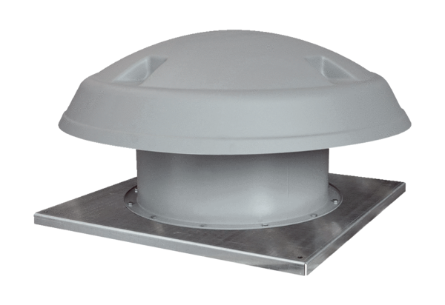Axial roof fan DAD 80/4Packing unit: 1 pieceRange: C
Article number: 0073.0076Manufacturer: MAICO

