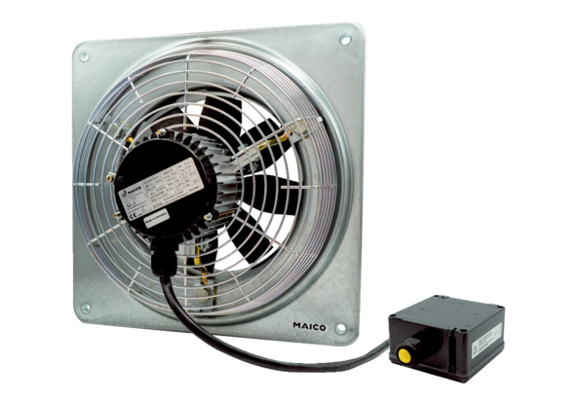Axial wall fan DZQ 20/4 B Ex tPacking unit: 1 pieceRange: C
Article number: 0083.0200Manufacturer: MAICO

