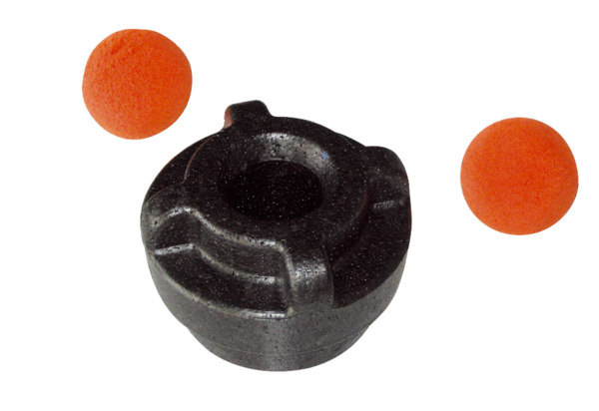Cleaning kit MF-R75Packing unit: 1 pieceRange: K
Article number: 0058.0012Manufacturer: MAICO

