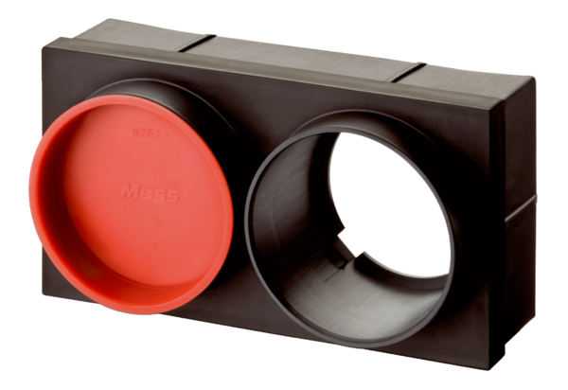Slide-in adaptor MF-WE75Packing unit: 1 pieceRange: K
Article number: 0059.0972Manufacturer: MAICO

