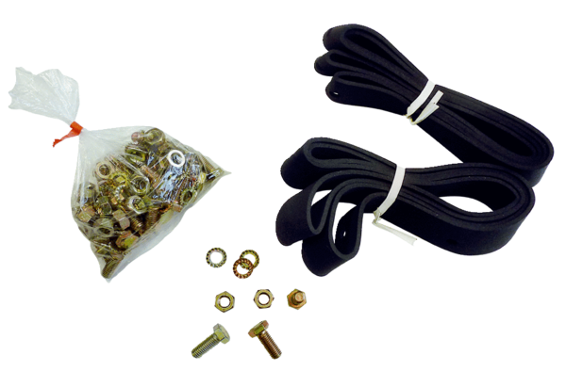Mounting and sealing material BD 45Packing unit: 1 pieceRange: C
Article number: 0092.0137Manufacturer: MAICO

