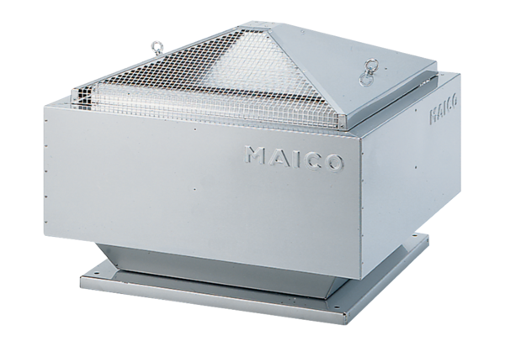Centrifugal roof fan MDR 25 ECPacking unit: 1 pieceRange: E
Article number: 0087.0024Manufacturer: MAICO

