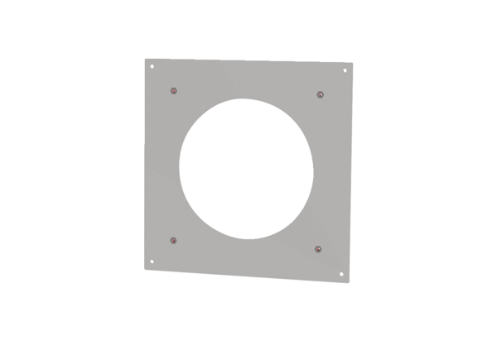Fixing plate PPB 30 ARW BBPacking unit: 1 pieceRange: K
Article number: 0093.1527Manufacturer: MAICO

