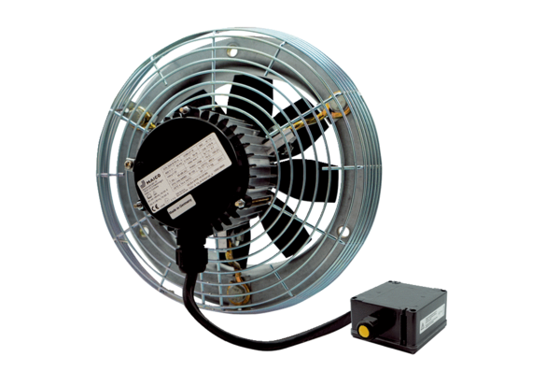Axial wall fan DZS 50/6 B Ex ePacking unit: 1 pieceRange: C
Article number: 0094.0128Manufacturer: MAICO

