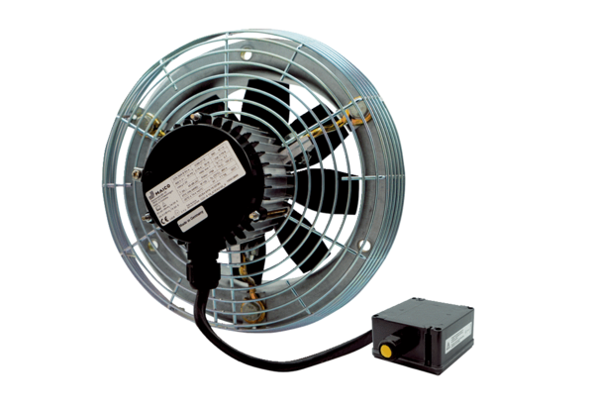Axial wall fan DZS 50/4 B Ex ePacking unit: 1 pieceRange: C
Article number: 0094.0129Manufacturer: MAICO

