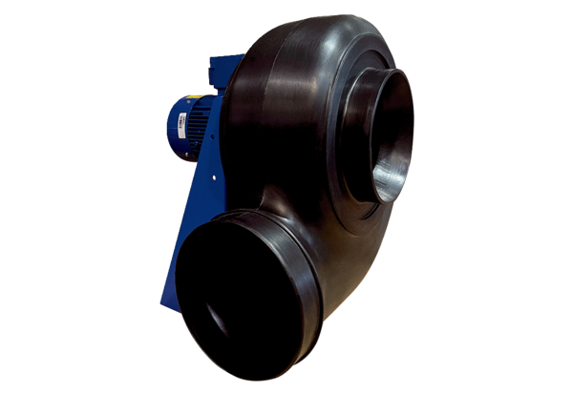Centrifugal blower GRK R 56/4 D ExPacking unit: 1 pieceRange: C
Article number: 0073.0458Manufacturer: MAICO

