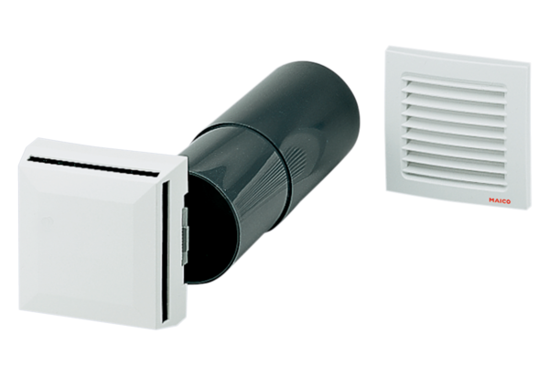Supply air element ZE 10 IBPacking unit: 1 pieceRange: K
Article number: 0152.0046Manufacturer: MAICO

