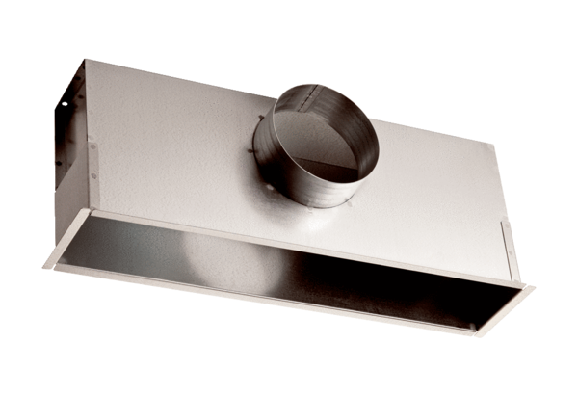Installation box EK 62/22Packing unit: 1 pieceRange: C
Article number: 0149.0086Manufacturer: MAICO

