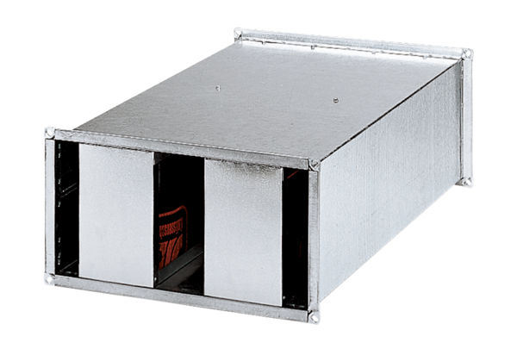Channel sound absorber KSP 25/15Packing unit: 1 pieceRange: D
Article number: 0092.0302Manufacturer: MAICO

