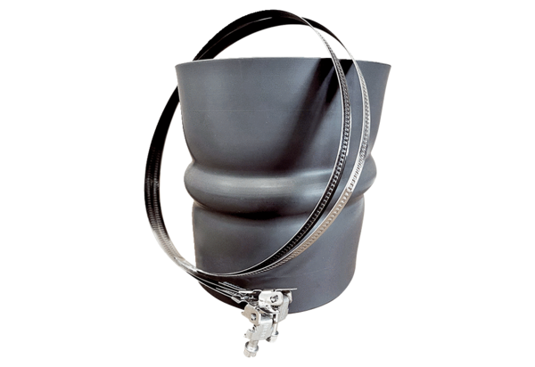Flexible cuff STKI 25Packing unit: 1 pieceRange: C
Article number: 0073.0489Manufacturer: MAICO

