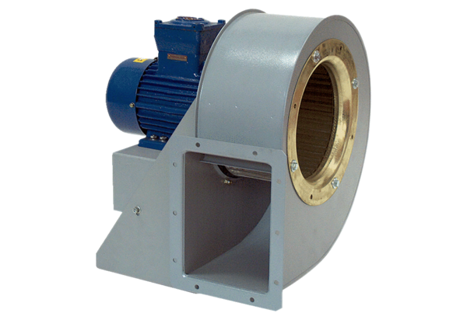Centrifugal blower GRM HD 28/4-2 ExPacking unit: 1 pieceRange: C
Article number: 0073.0404Manufacturer: MAICO

