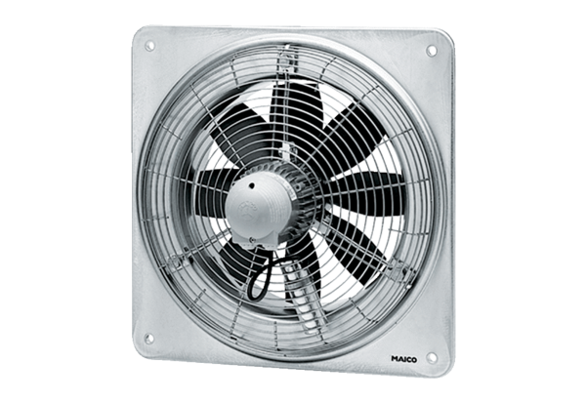Axial wall fan DZQ 60/86 BPacking unit: 1 pieceRange: C
Article number: 0083.0071Manufacturer: MAICO

