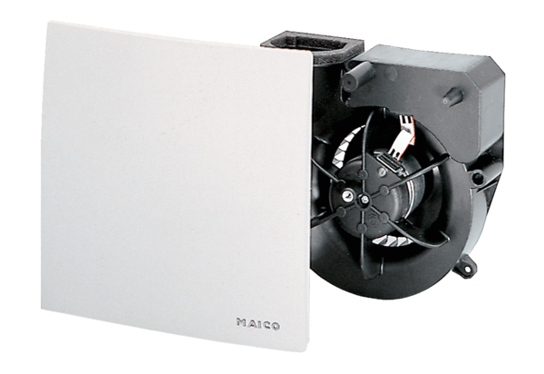Fan insert ER 60 VZPacking unit: 1 pieceRange: B
Article number: 0084.0101Manufacturer: MAICO

