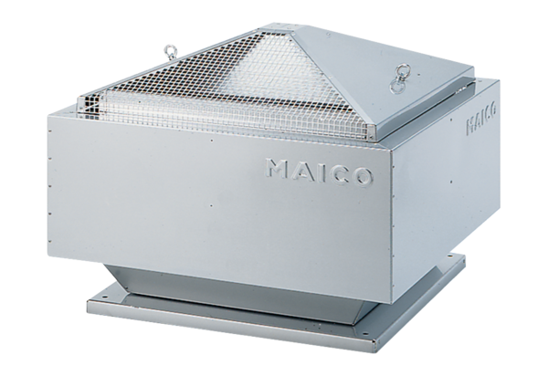Centrifugal roof fan DRD 18/4 BPacking unit: 1 pieceRange: C
Article number: 0087.0100Manufacturer: MAICO

