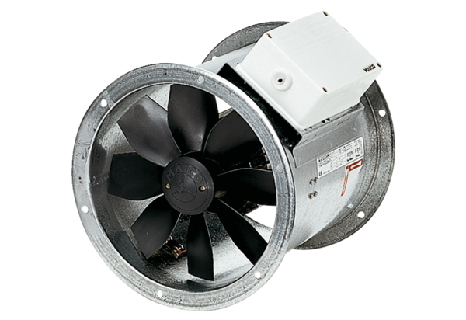Axial duct fan DZR 60/84 BPacking unit: 1 pieceRange: C
Article number: 0086.0055Manufacturer: MAICO

