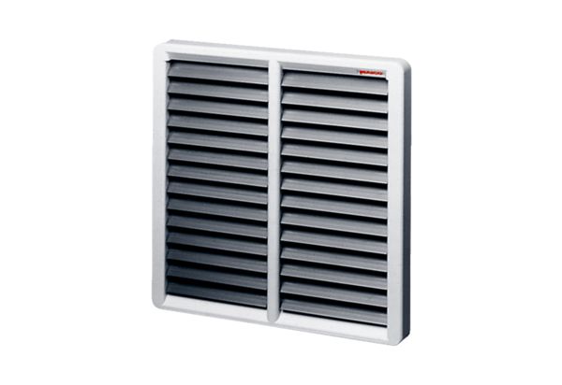Shutter, manual RS 60Packing unit: 1 pieceRange: C
Article number: 0151.0345Manufacturer: MAICO

