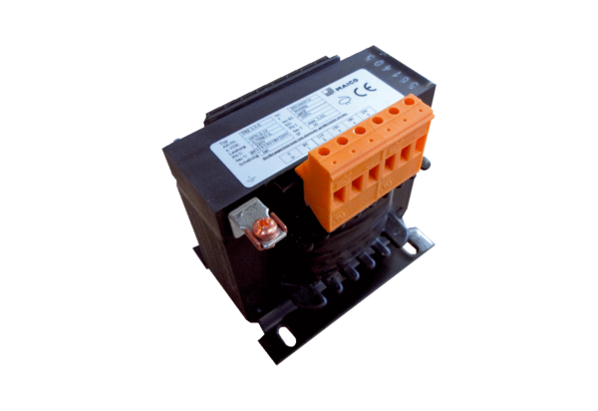5-step transformer, control cabinet TRE 1,6 S-2Packing unit: 1 pieceRange: C
Article number: 0157.0162Manufacturer: MAICO

