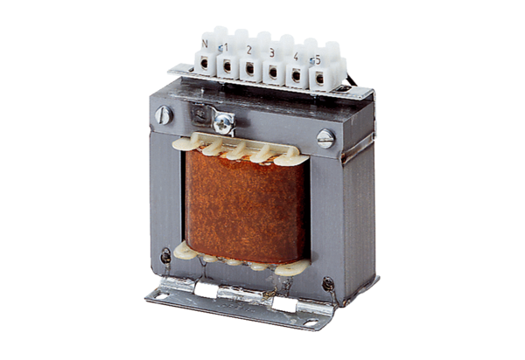5-step transformer, control cabinet TRE 1,6 SPacking unit: 1 pieceRange: C
Article number: 0157.0744Manufacturer: MAICO

