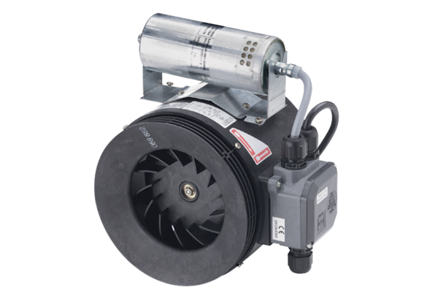Semi-centrifugal duct fan ERM 25 Ex e/60 HzPacking unit: 1 pieceRange: C
Article number: 0080.0375Manufacturer: MAICO

