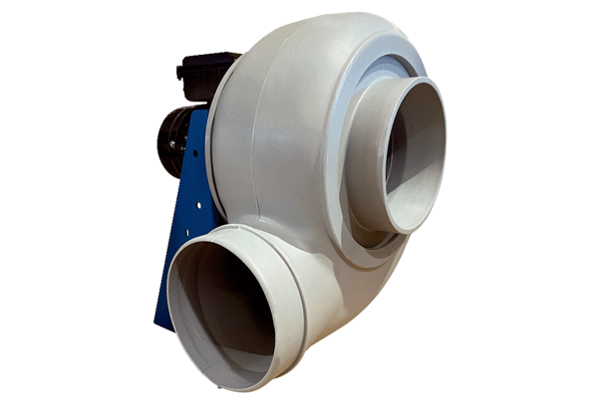Centrifugal blower GRK R 31/2 EPacking unit: 1 pieceRange: C
Article number: 0073.0509Manufacturer: MAICO

