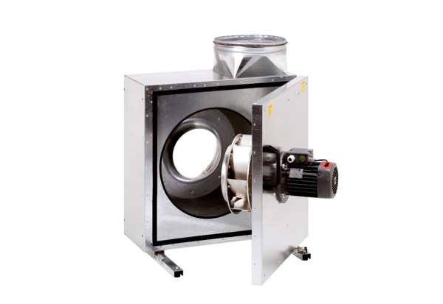Sound-insulated ventilation box EKR 31-2Packing unit: 1 pieceRange: C
Article number: 0080.0884Manufacturer: MAICO

