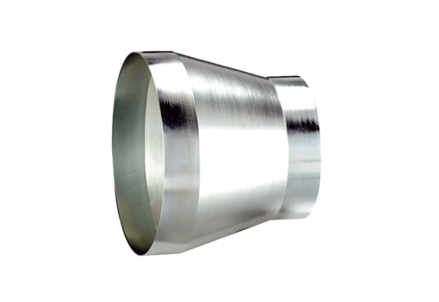Reducer REM 25/20 ExPacking unit: 1 pieceRange: C
Article number: 0055.0309Manufacturer: MAICO

