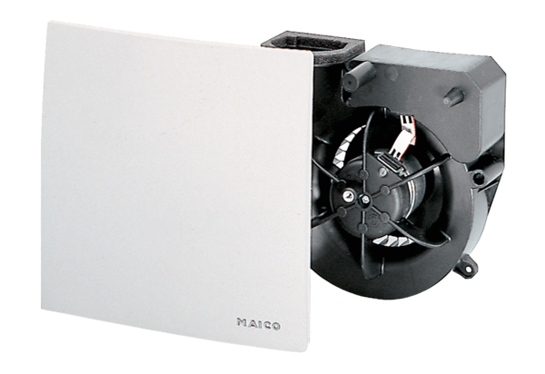Fan insert ER 100 GPacking unit: 1 pieceRange: B
Article number: 0084.0133Manufacturer: MAICO

