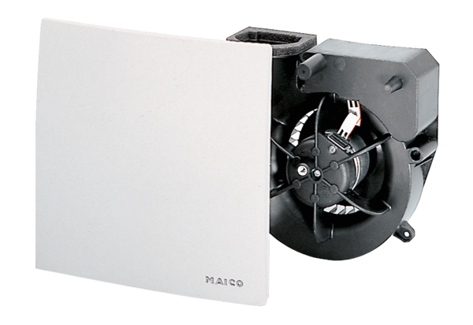Fan insert ER 100 IPacking unit: 1 pieceRange: B
Article number: 0084.0135Manufacturer: MAICO

