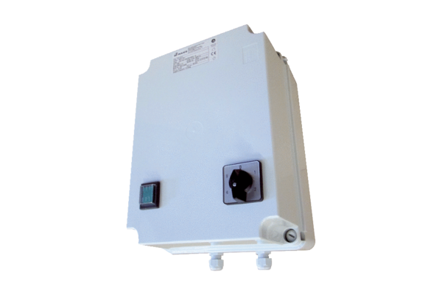5-step transformer TRE 6,5-2Packing unit: 1 pieceRange: C
Article number: 0157.0160Manufacturer: MAICO

