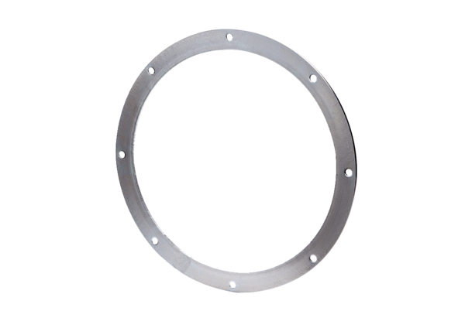Counter flange GF 45Packing unit: 1 pieceRange: C
Article number: 0056.0007Manufacturer: MAICO

