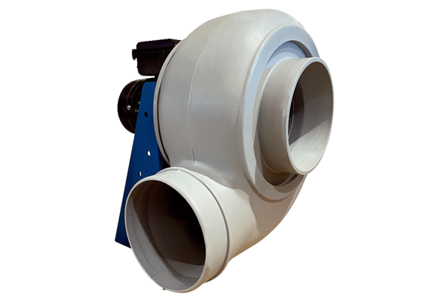Centrifugal blower GRK R 56/6 DPacking unit: 1 pieceRange: C
Article number: 0073.0531Manufacturer: MAICO

