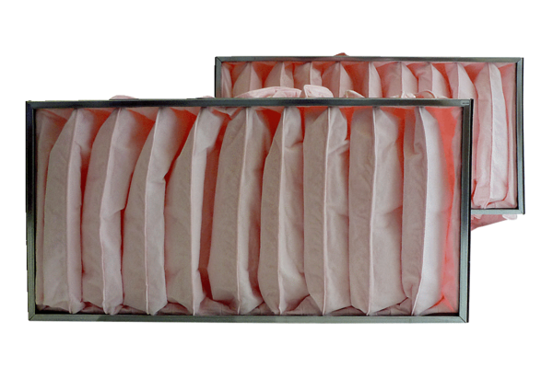Air filter, replacement KF 50-7Packing unit: 2 piecesRange: D
Article number: 0093.0868Manufacturer: MAICO

