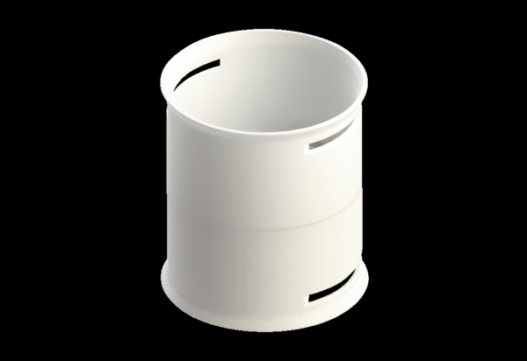Connecting sleeve MA-M75Packing unit: 1 pieceRange: K
Article number: 0059.2131Manufacturer: MAICO

