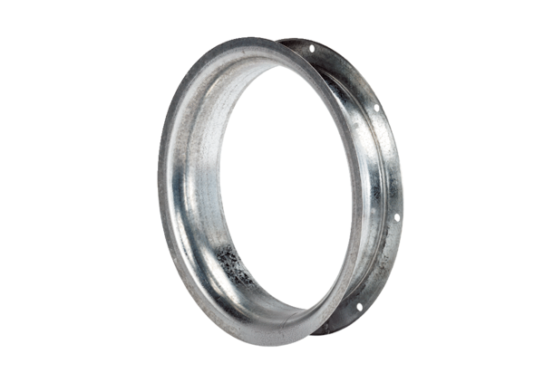Suction nozzle AD 45Packing unit: 1 pieceRange: C
Article number: 0180.0624Manufacturer: MAICO

