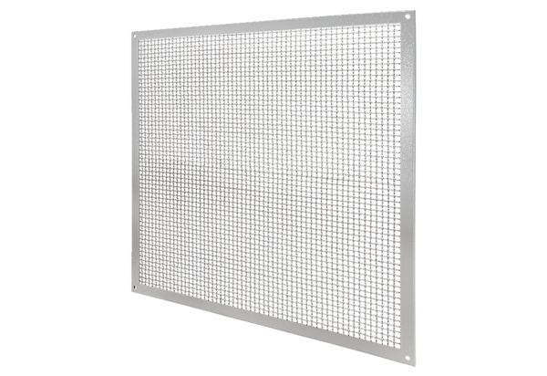Protection against accidental contact SGSI 71Packing unit: 1 pieceRange: C
Article number: 0073.0343Manufacturer: MAICO

