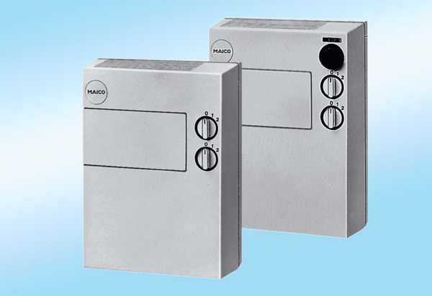Fresh air unit POL 100Packing unit: 1 pieceRange:
Article number: 0082.0052Manufacturer: MAICO

