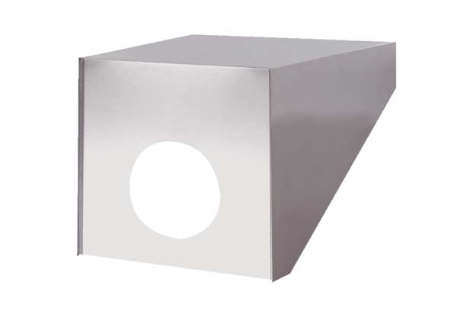Roof cowl PP 45 DH 31-35Packing unit: 1 pieceRange: K
Article number: 0093.1319Manufacturer: MAICO

