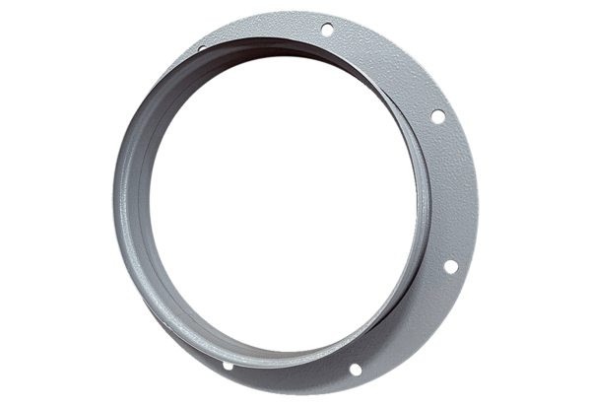Intake socket ASI 45Packing unit: 1 pieceRange: C
Article number: 0073.0440Manufacturer: MAICO

