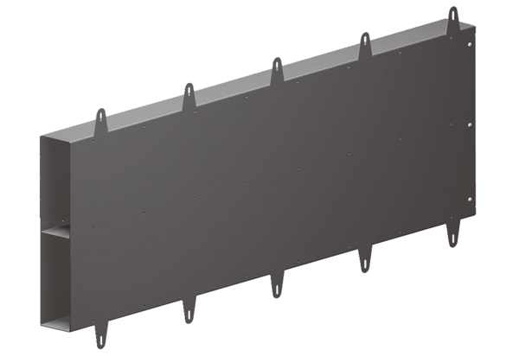Soffit element extension Duo LEVPacking unit: 1 pieceRange: K
Article number: 0093.0089Manufacturer: MAICO

