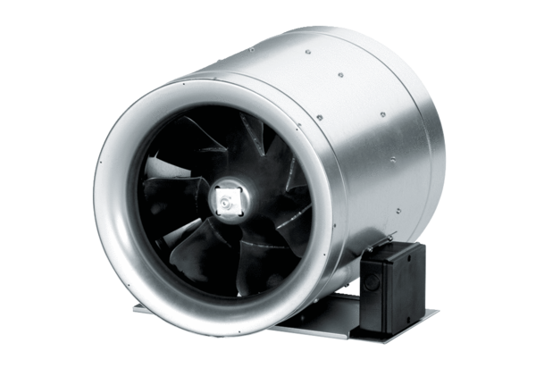Diagonal fan EDR 35Packing unit: 1 pieceRange: C
Article number: 0080.0658Manufacturer: MAICO

