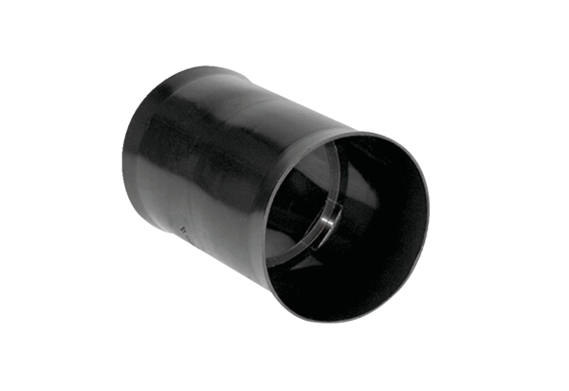Insertion sleeve MF-FSM63Packing unit: 1 pieceRange: K
Article number: 0059.0973Manufacturer: MAICO

