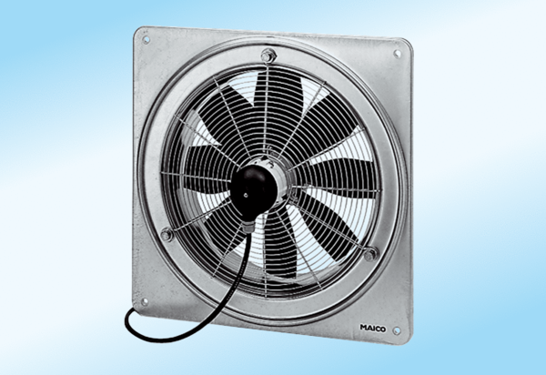Axial wall fan DZQ 25/4 A-ExPacking unit: 1 pieceRange: C
Article number: 0083.0760Manufacturer: MAICO

