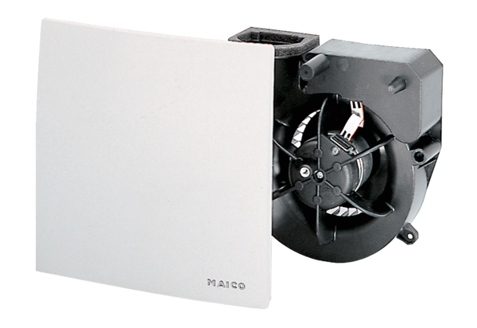Fan insert ER 100 GVZPacking unit: 1 pieceRange: B
Article number: 0084.0139Manufacturer: MAICO

