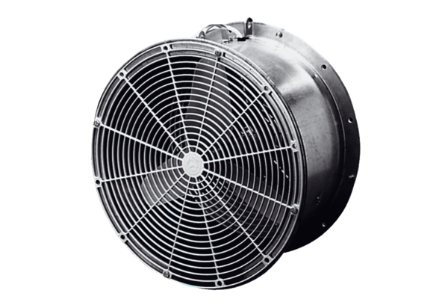Greenhouse fan EFG 35 DPacking unit: 1 pieceRange: C
Article number: 0081.0406Manufacturer: MAICO

