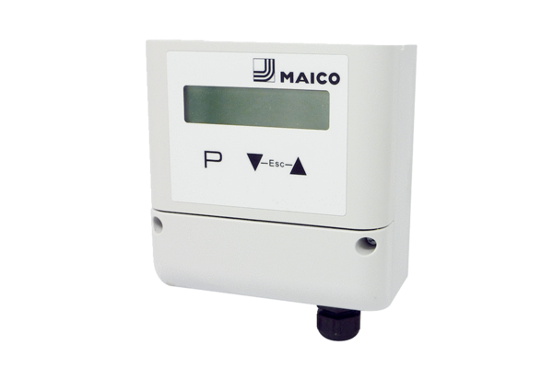Volumetric flow setpoint adjuster DZS MDR-VG AVCPacking unit: 1 pieceRange: E
Article number: E157.1637.0000Manufacturer: MAICO

