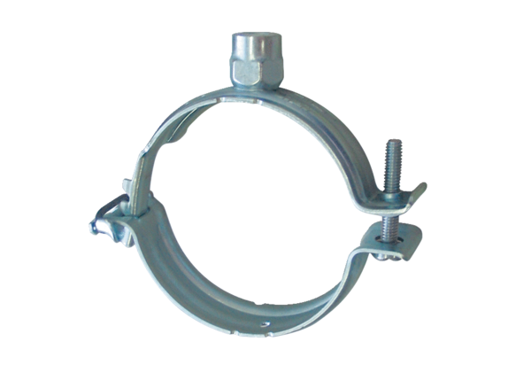Mounting clamp MF-S90Packing unit: 1 pieceRange: K
Article number: 0018.0469Manufacturer: MAICO

