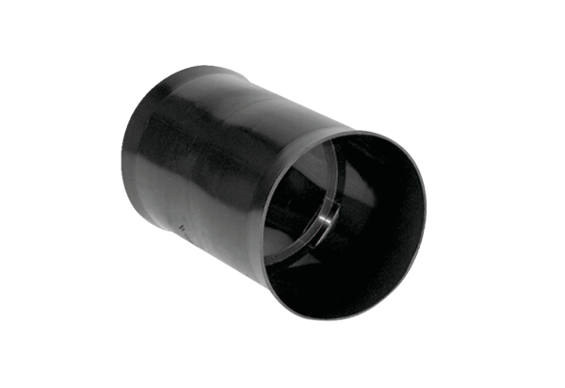Insertion sleeve MF-FSM90Packing unit: 1 pieceRange: K
Article number: 0059.0975Manufacturer: MAICO

