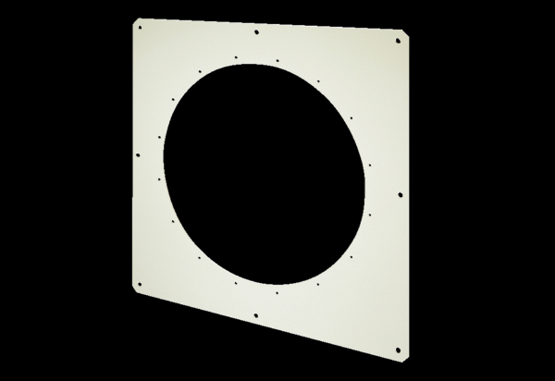Square wall plate QW 80Packing unit: 1 pieceRange: C
Article number: 0053.0014Manufacturer: MAICO

